* Create new Spring boot starter project.

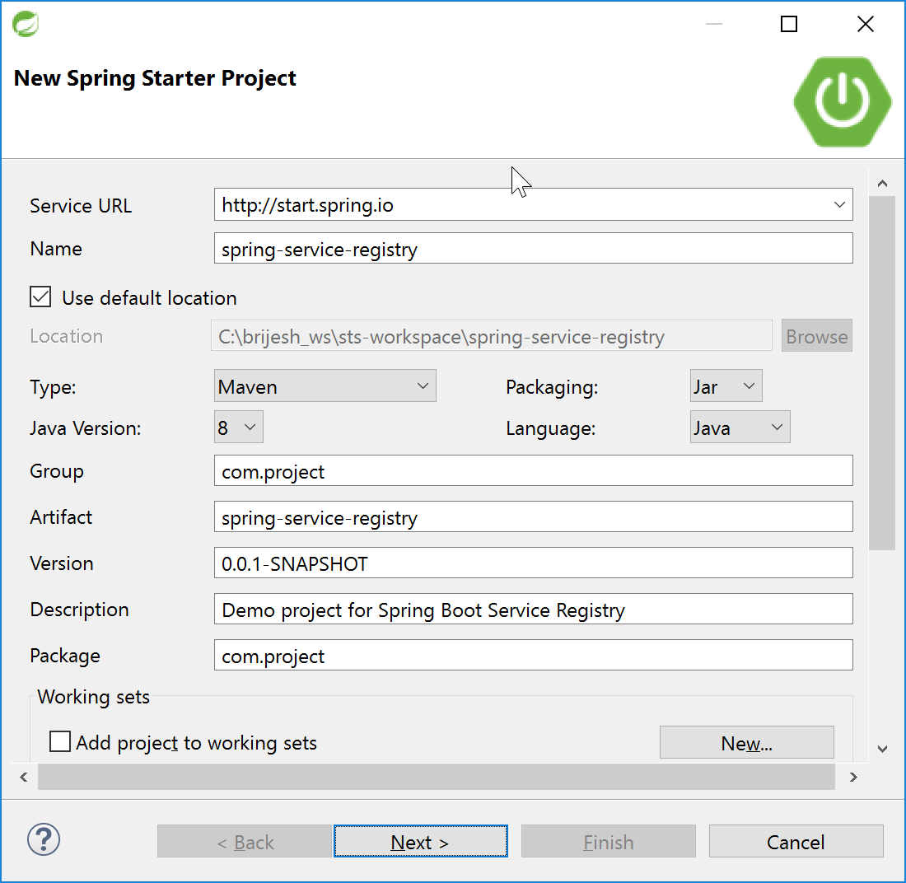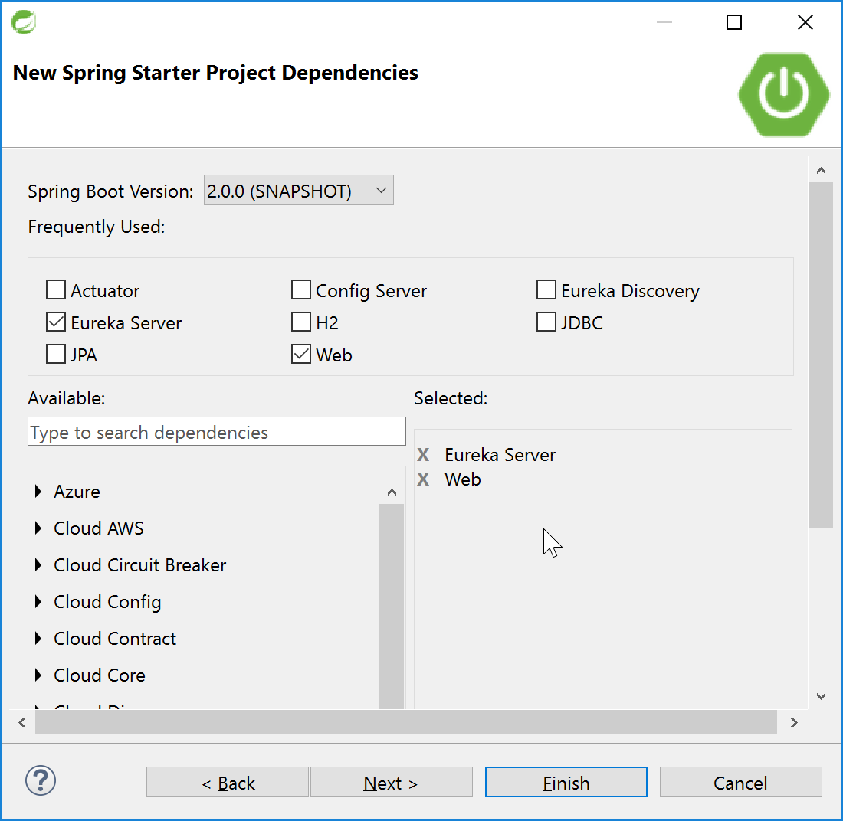

* Create the application.yml file with below content

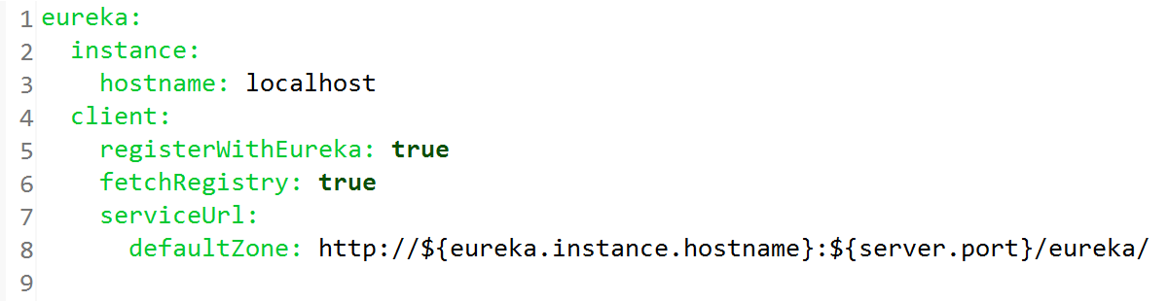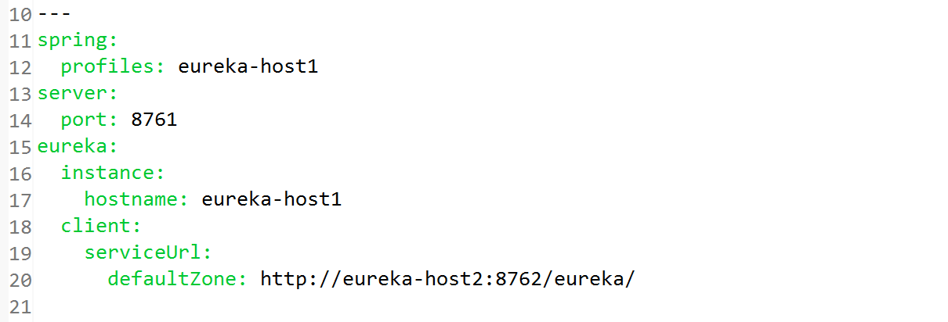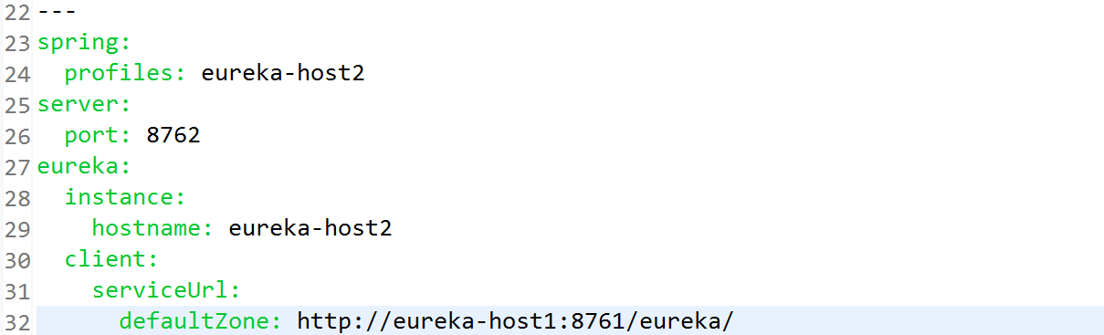

* Add below annotation in bootstrap starter java application class.

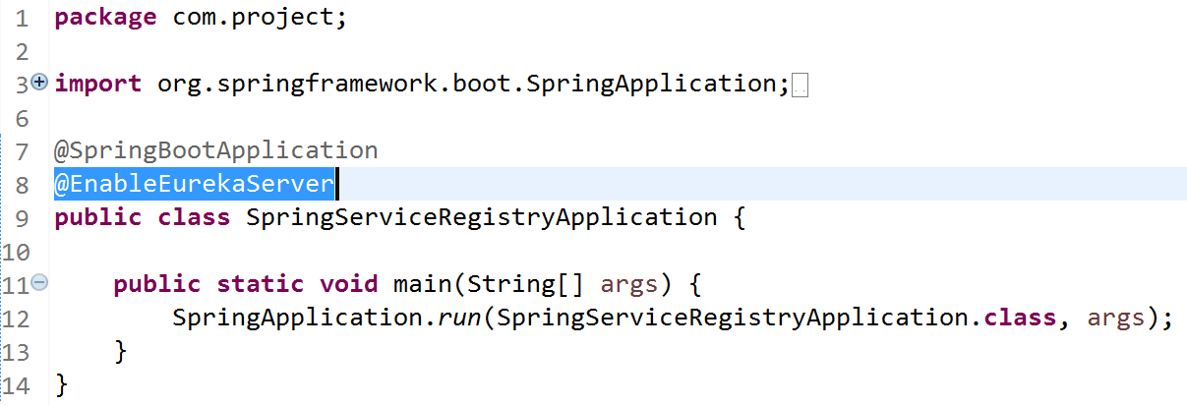

* Access below urls to verify.
  + <http://eureka-host1:8761/>
  + <http://eureka-host1:8762/>
  + <http://eureka-host1:8762/health>
  + <http://eureka-host1:8762/env>
  + <http://eureka-host1:8762/beans>